17906 – ONBOARDING: New VEO Admin Menu Option

STORY LINK: [url](https://dev.azure.com/BuildOnTechnologies/VeoDesignStudio/_workitems/edit/17906)

# Criteria:

1. Create a new menu option in VeoAdmin under Reports called Tile Patterns 2
2. Clicking the new menu option should route the user to a new page named Tile Pattern Reports 2

# Changes:

## Criteria 1

Menu now contains a new menu option Reports\Tile Patterns 2  
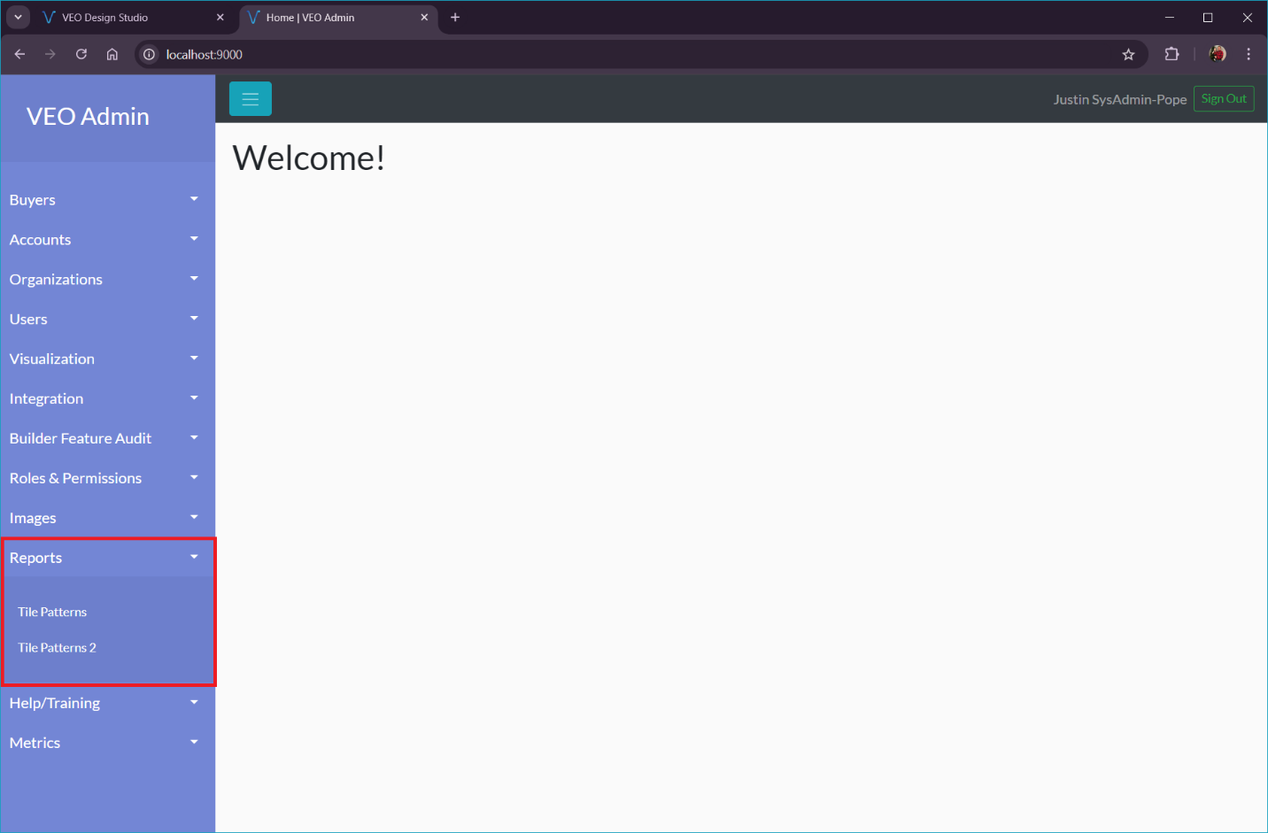

## Criteria 2

Clicking the menu option opens up Tile Pattern Reports 2

## Code

### App.ts

* Added route for TilePattern2

### Component: jkp-new-component

* Files:
  + jkp-new-component.ts
  + jkp-new-component.scss
  + jkp-new-component.html